**#Python program to print series**

largest_no=int(input('Enter largest number of series:'))

for i in range(0,largest_no+1,1):

print(i, end=',')

largest_no=int(input('\n Enter largest number of series:'))

for i in range(largest_no,-1,-1):

print(i, end=',')

**OUTPUT**

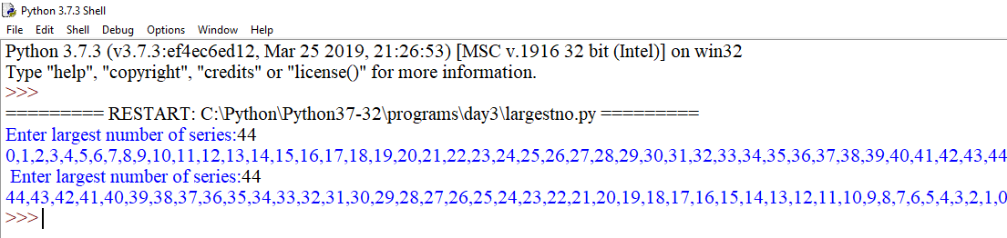

**#Python program to print series using functions**

def seriesasc():

largest_no=int(input('Enter largest number of series:'))

for i in range(0,largest_no+1,1):

print(i, end=',')

def seriesdesc():

largest_no=int(input('\n Enter largest number of series:'))

for i in range(largest_no,-1,-1):

print(i, end=',')

seriesasc()

seriesdesc()

**OUTPUT**

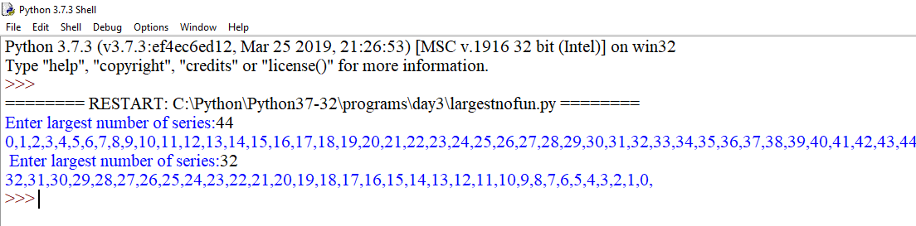

#**Python program to print series and taking increment input from user**

largest_no=int(input("\nEnter largest number of series:"))

increment=int(input("\nEnter increment number of series:"))

for i in range(0,largest_no+1,increment):

print(i,end=',')

**OUTPUT**

